**Sam Hyde | 1team | bicflame | joeyy**

Hi, my name is Eve. I formerly worked freelance doing 3d work for sam hyde for an unreleased game he was working on for a few months. In my time working freelance, I worked around sam hyde and all of 1team, bicflame, joeyy, and was around 1team members and associates like facey etc. I started working with a rough understanding of sam just being an edgy comedian and had no idea who bicflame, joeyy, or what 1team even was. I was happy to get some 3d freelance work, but here’s what I was met with, how I was far from the first person to experience first hand how bad things really were with sam hyde, and how I wound up packing my bags and leaving in the night.

Before I left Rhode Island, I tried to change things and confronted things that made me uncomfortable and was met with blank stares and emptiness. After countless confrontations with 1team and bic, I realized nothing was changing. I was wondering when things would get better and they never did, I confronted everyone about the drugs… about everything… but nothing was changing. So I packed my bags in the middle of the night and left after confronting them one last time. This is a conversation between bicflame (julien unger) and me that I will let speak for itself: When these people get caught saying these hateful hurtful things and are confronted, it all suddenly turns into a joke. They are outwardly hurtful and believe as long as they say hurtful awful things behind people's backs, it makes it okay. It all begins with true belief and is guised under humor when presented publicly, and isn’t even guised in humor in private.

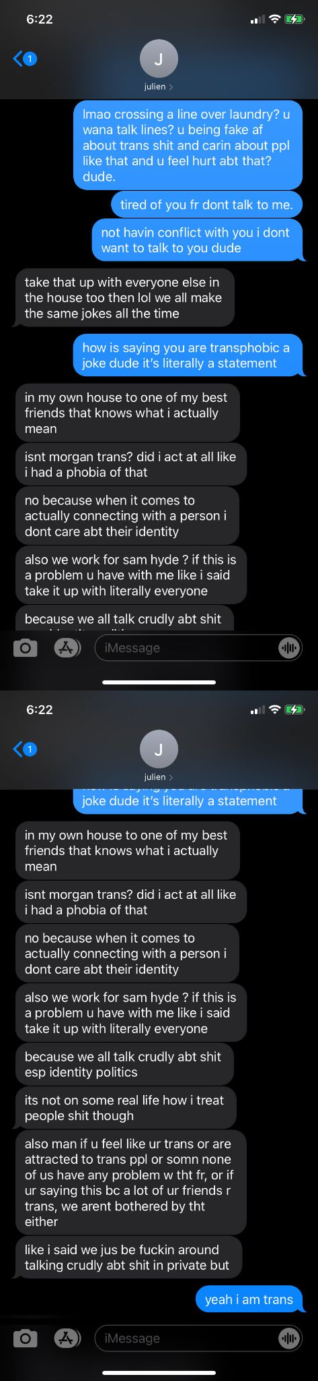

Heres another screenshot of a convo after I packed my bags and left Rhode Island. Bic 1team and sam have guilty consciences its not that they are ignorant or oblivious to offensive and hurtful things they do and say, but when confronted they push it off as comedy and just banter. Its not. Its either projection about things they really do / have done, and every chance they’ve somehow been given to change, they just regress deeper and deeper into themselves to show how truly vile they are. I’ll be focusing on bic and 1team for the next few screenshots, but after will be just how twisted sam hyde and his past is, and how mindbendlingly insane it is for anyone to work with or still be associated with sam hyde after knowing any of this stuff is. 1team and Sam Hyde’s manipulation is good enough to keep bringing people into the fold and hide who they really are and their pasts behind projection and hate that's guised behind comedy. Here’s bicflame (julien unger)’s feelings being quoted after I started finding out everything, having enough of everything, and leaving Rhode Island. Bicflame (julien unger) is the person within the quotes of this screenshot:

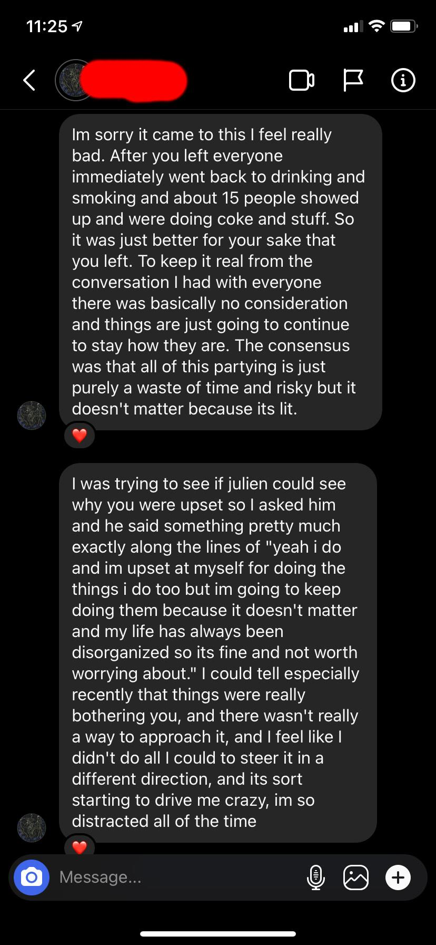

Bicflame (Julien Unger) consistently spouts this stuff publicly, yet wipes his instagram and twitter every time hes called out for something or faced with consequences and reality. He may say hes a “really really nice guy” and put up a flimsy facade, but like the screenshot aforementioned this is what he really feels underneath it all. For whatever twisted reason he somehow thinks anything he says and does is fine if its in private and behind people's backs. It dosen’t make it any less hurtful if you say or do any of this stuff behind peoples backs.

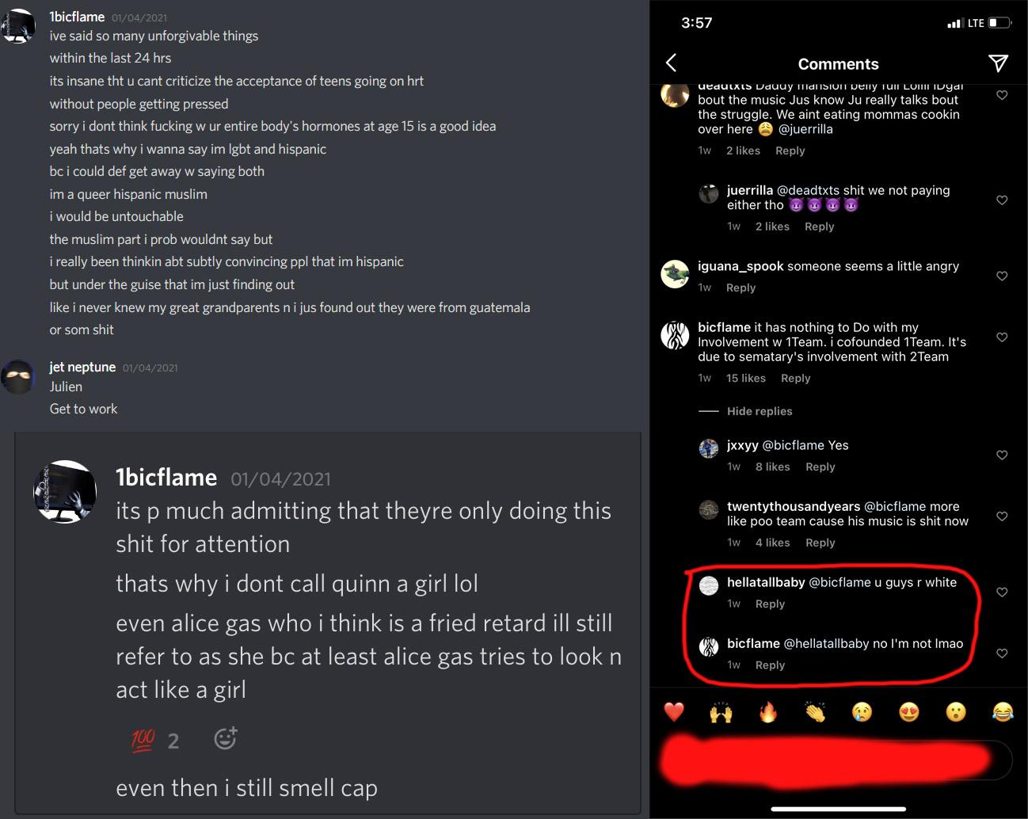

While using me as a token transgender card whenever confronted about transphobia within 1team and from sam hyde, they also continuously use 1team member Facy as an excuse for saying the n word as well as facy using the n word himself. Facy is Indonesian. Facy is not black.

One instance I had between Joeyy and I was at a houseparty at my house in Providence. After already being misgendered by 1team being introduced to numerous people at the party, Joeyy comes up to me as I'm standing at the kitchen island and says:

**Joeyy:** “so I hear you have like a new boyfriend or something now?”

**Me:** “Yeah I do! Hes really awesome I love him so fucking much”

**Joeyy:** “Okay so is he like gay?”

**Me:** “No I’m a woman so. He’s straight? He’s my boyfriend and im his girlfriend why do you care?”

**Joeyy:** “Okay hahaha well that’s a real funny way to go around it.”

Another huge thing is the drugs. I’ve been sober for over 4 years and was addicted to molly and other drugs, and was persistently outspoken about how much it was an issue for me to directly be around. At first they all hid it well especially Joeyy.

This is an interaction that took place at my old house between Joeyy and I and wasn’t the last of its kind to say the least. (the one that the music video for Joeyy-Shirt was shot in)

**Joeyy:** “bro take a sip.”

**Me:** “I’m good thanks though.”  
**Joeyy:** “dude come on just take a sip its sweet it tastes like candy haha.”

**Me:** “I’m completely fine no way im good dude u already know i was an addict what’s your deal.”

**Joeyy:** “okay whatever dude.”

Of the many times I talked to joeyy about stressful things etc i would be literally met with “Dude why don’t you just smoke weed about it. Just try smoking weed.”

At first seeing them do drugs was every once in a while but it turned into full blown sipping fake fent lean on weekdays with kpins, molly, whatever. I confronted Joey about it being a problem on multiple occasions and voicing my concerns cos of what I’ve seen and have been through and have lost. I saw Joey and 1team slipping and getting fully engrossed by drugs and I was scared. Every time 1team people would come over it was either buying drugs and having drugdealers come over, or to just do drugs. It is really sad how 1team and Joey’s identity has fully become sipping lean and glorifying drug use. Every video and song is literally about and showing off drugs. The line from Joeyy’s song Shirt is about his girlfriend being angry about him buying and sipping lean and I was directly told this while he played it in my car before it dropped. “I did not mean to do you wrong, I’m sorry for what it's worth” -Lyric from Joeyys song shirt.

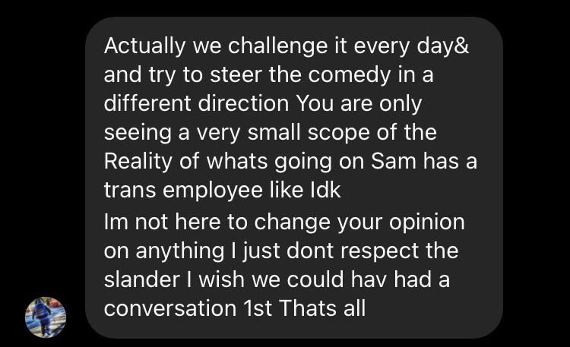

Screenshot from Joey

What is there to steer away from? If sam and 1team arent harmful and racist, homophobic, and transphobic, what is there to steer away from?

Bicflame and 1team not only knowingly choose to continue working with sam hyde after knowing how bad everything really is, but are also associating with other people all the time that have been canceled for irrefutable reasons and it blows my mind. The fake fame, lifestyle, and money, and fake drugs are all too addictive for these people to see logic or reason.

“I’m going to work with rozz I literally don’t care. I don’t care that he’s a pedo, no one cares anymore, everyones moved on.”

Reference for as to who rozz dyliams is and proof they are mutuals as well as a video saying hes bros with rozz and Sam hyde :

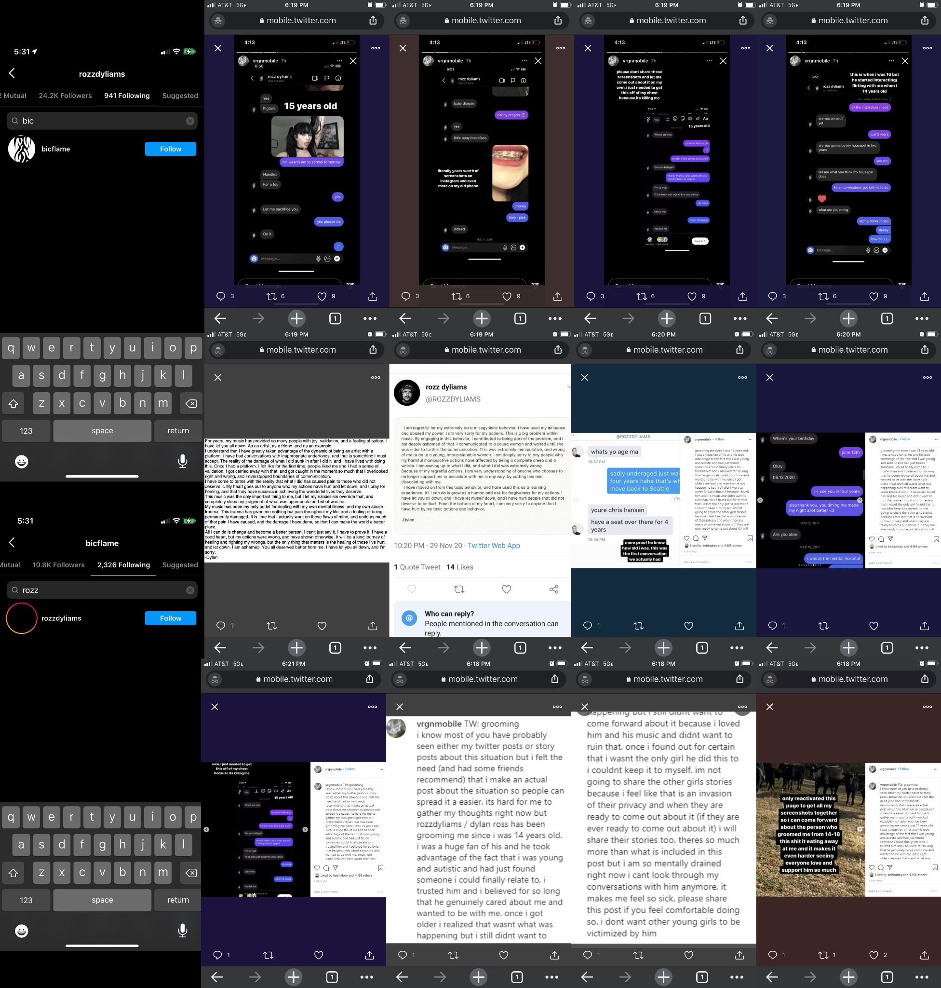

-----INSERT BIC ROS VIDEO----

The most massive thing of all is how sam hyde, bicflame (julien unger) and others treat women and girls. In real life there is just so much, but online is a completely different beast with sam hyde, bicflame, and 1team. It has no end. Online they are able to have everyone at their fingertips with no irl physical ramifications and are able to do what they do way easier. Since sam hyde’s history with the aforementioned goes so deep and for so long with so many targets, I’ll just start with some surface level bicflame from 1team stuff. Bicflame is literally in every girl’s dm ever just complete dragnet hitting up anyone who breathes. As a start, Bicflame (julien unger) is somehow banned from both Tinder and Uber. Proof bicflame is banned from uber:

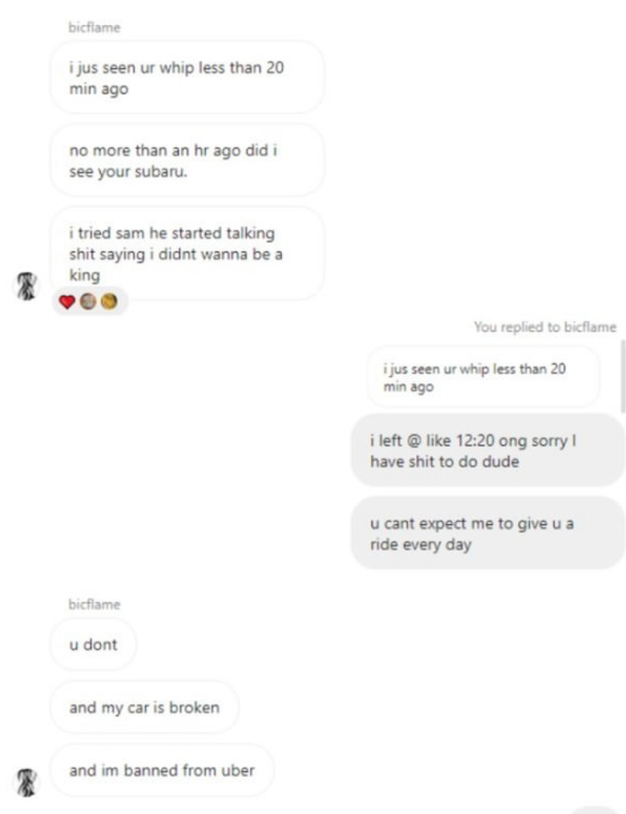

Here’s an instance of how the conversations go between bicflame and who he messages and will let what he talks about doing and how he talks speak for itself because I truly have no words to describe how it makes me feel. I hope more people feel comfortable and confident enough after this to come forward with their own experiences big or small with bicflame, 1team, or sam hyde. Again, this is just surface level with bicflame and 1team, but is known amongst themselves, and none of them care. heads are turned the other way.



For sam hyde, it’s a long story of years upon years of indescribable things that I will leave mostly up to pictures below.

First off sam currently has a girlfriend that he lives with at the “office” that is pregnant and has outspokenly said will marry. This first person is credited in MDE works and is behind the alias @konzept.globe doing motion graphics etc. He also has a young girlfriend who he bought an apartment for, flew out to Providence, Rhode Island, told he was going to marry, and just recently got pregnant behind his first girlfriend who he lives with’s back. Knowing what I now know about sam hyde, I fear for these kids. The following is a chain of screenshots of the young girl sam got pregnant.



Apart from sam hyde’s outspoken far right views, I’ll leave the mass amount of pictures I found publicly available online to speak for themselves along with videos and audio recordings found publicly available that demonstrate how his comedy is actually just projection from his own character, things he has done, and is trying to hide by blurring the lines between comedy and his real life, along with information and personal history directly from another of sam hyde’s ex-employees who also previously dated sam hyde.

First here are a few examples showing that sam hyde is truly alt right, has nazi ties, and that his comedy often really is simply a projection who he really is created to blur the lines on what is comedy and what is his real life making it seem so absurd making the viewer doubt themselves on what is the real sam, and what is really his acting. There is no line and most of what he jokes about and uses in improv is directly from within himself and things he has done to people.

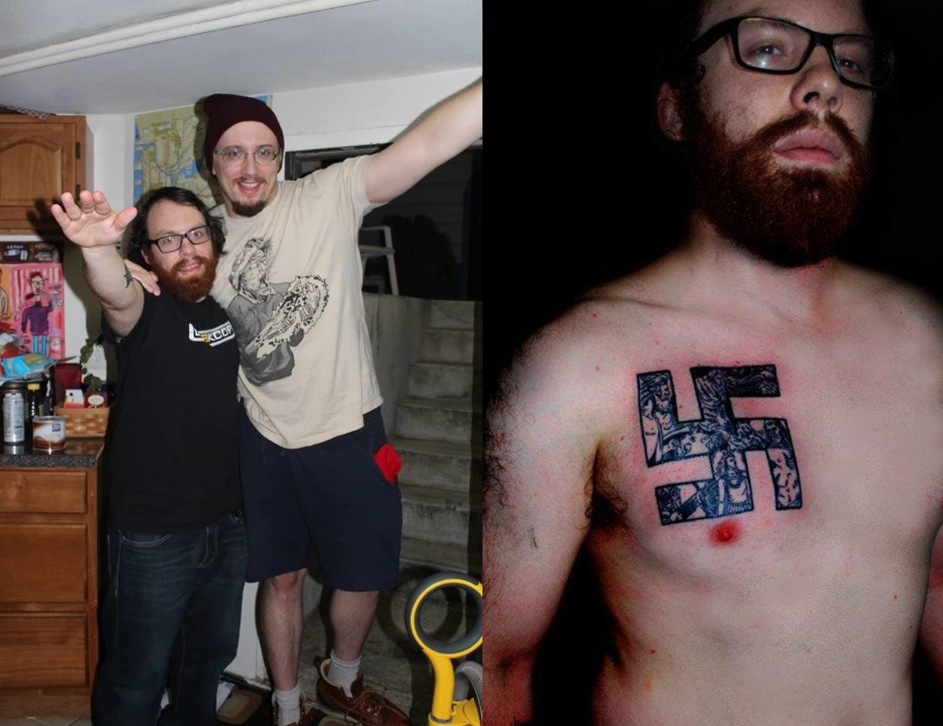

Pictured above: Sam Hyde and weev, a known Neo-Nazi and webadmin of the Neo-Nazi white supremacist message board *The Daily Stormer*.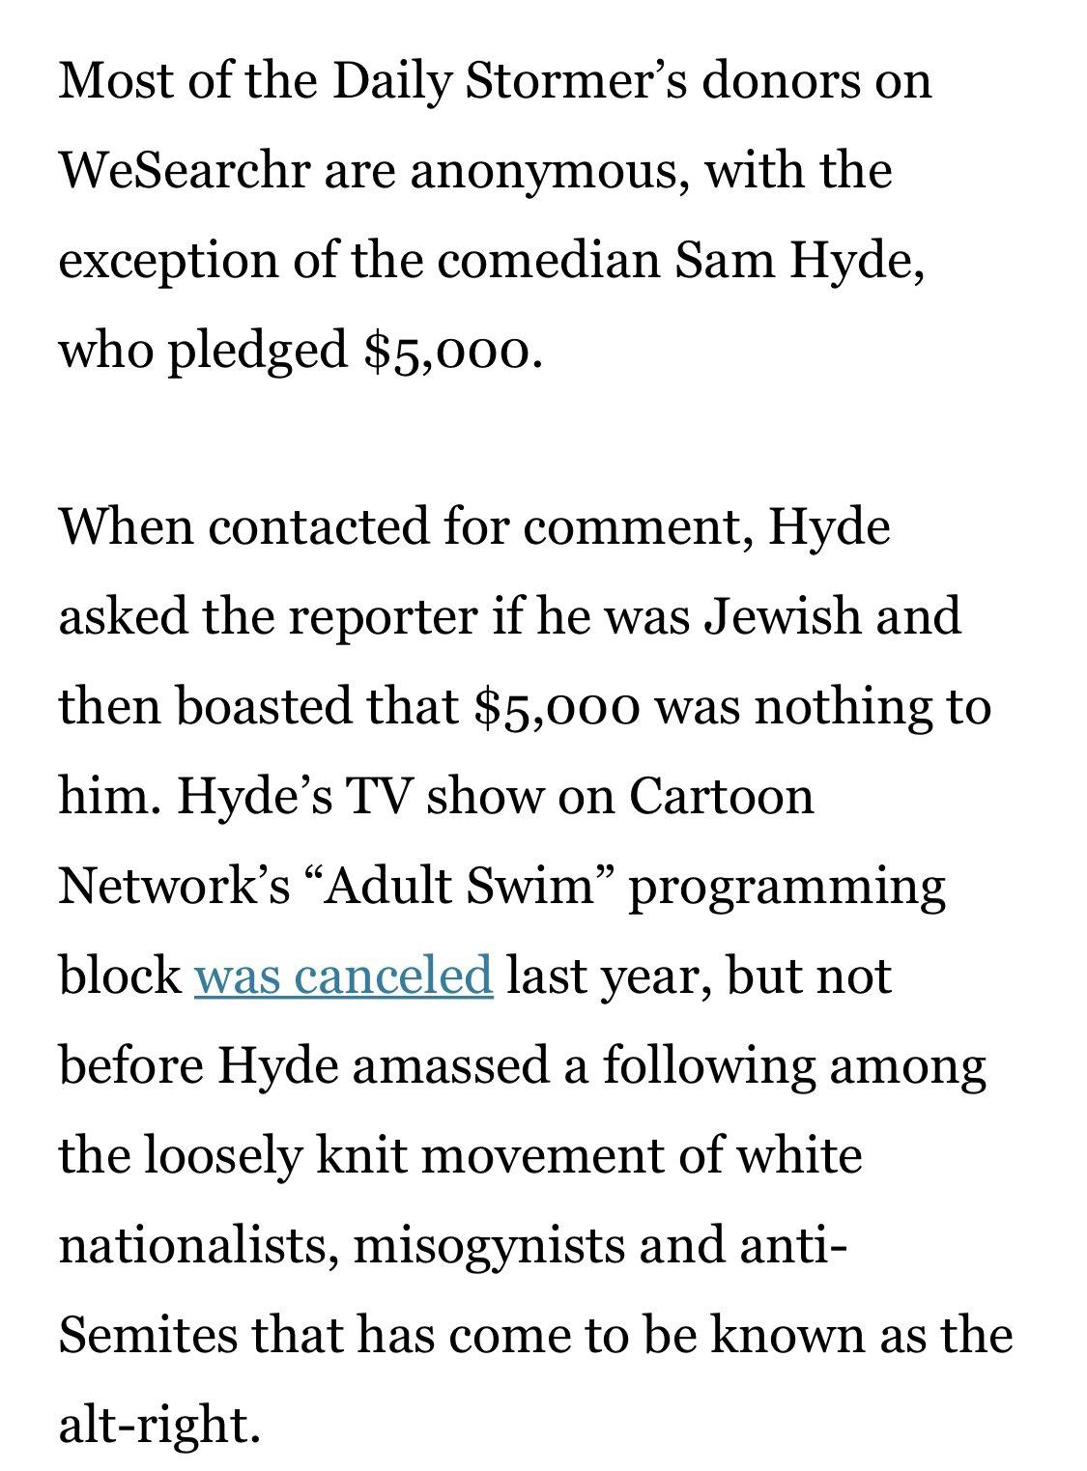

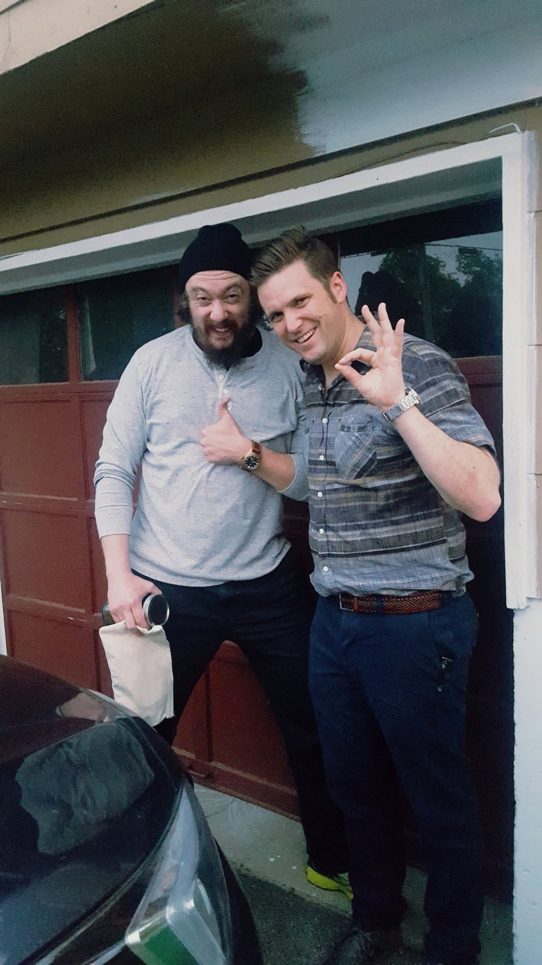

Pictured above: Sam hyde and Richard Bertrand Spencer who is an American neo-Nazi, antisemitic conspiracy theorist, and white supremacist who is known for his activism on behalf of the alt-right movement in 2016 and 2017.

----INSERT NICK FUENTS SAM HYDE MAGA VIDEO----

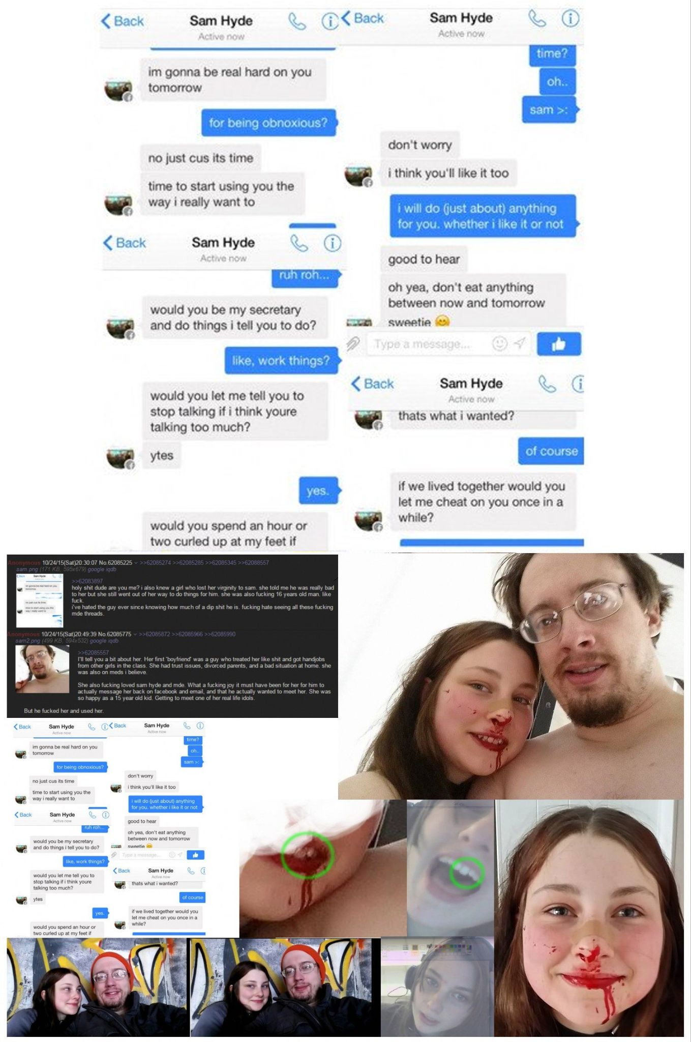

----INSERT SAM HYDE BOSTON ROSS VIDEO CLIP----

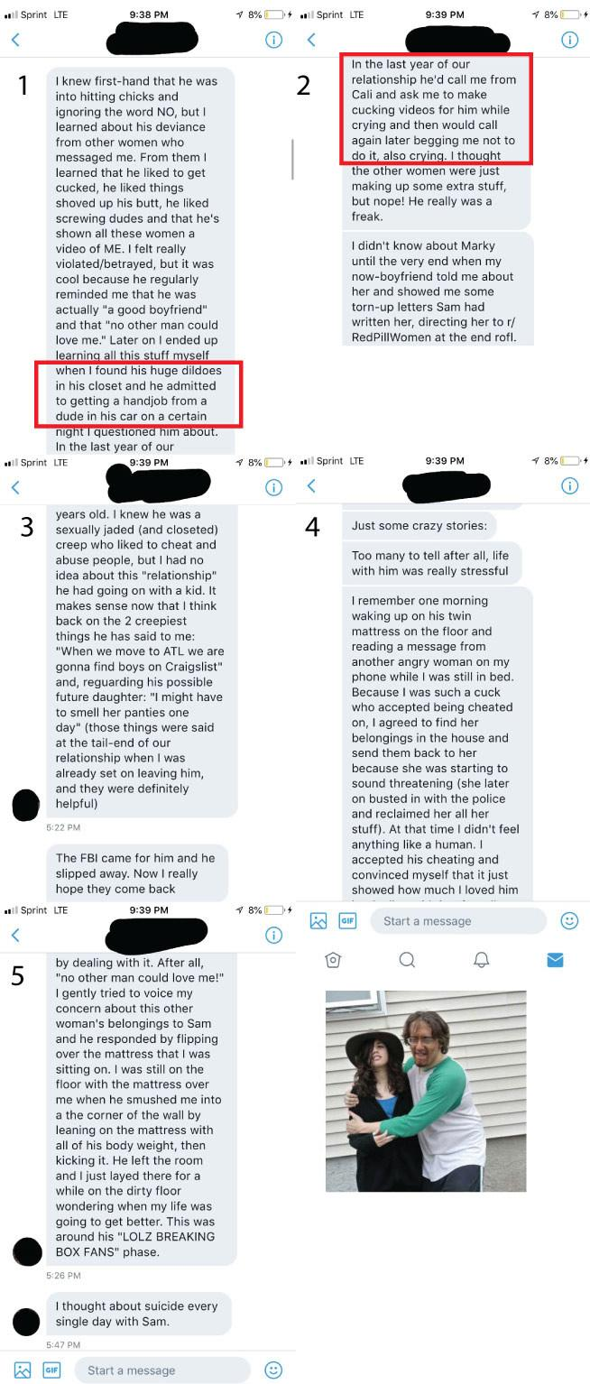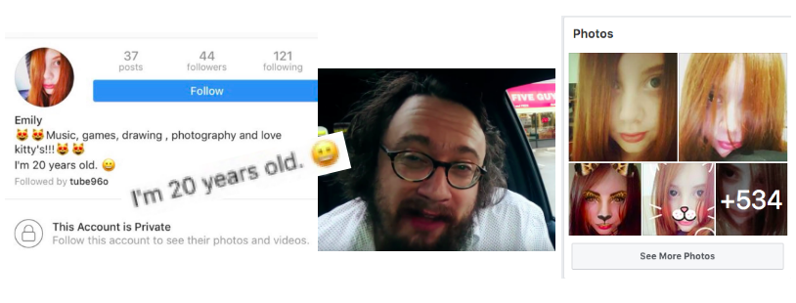

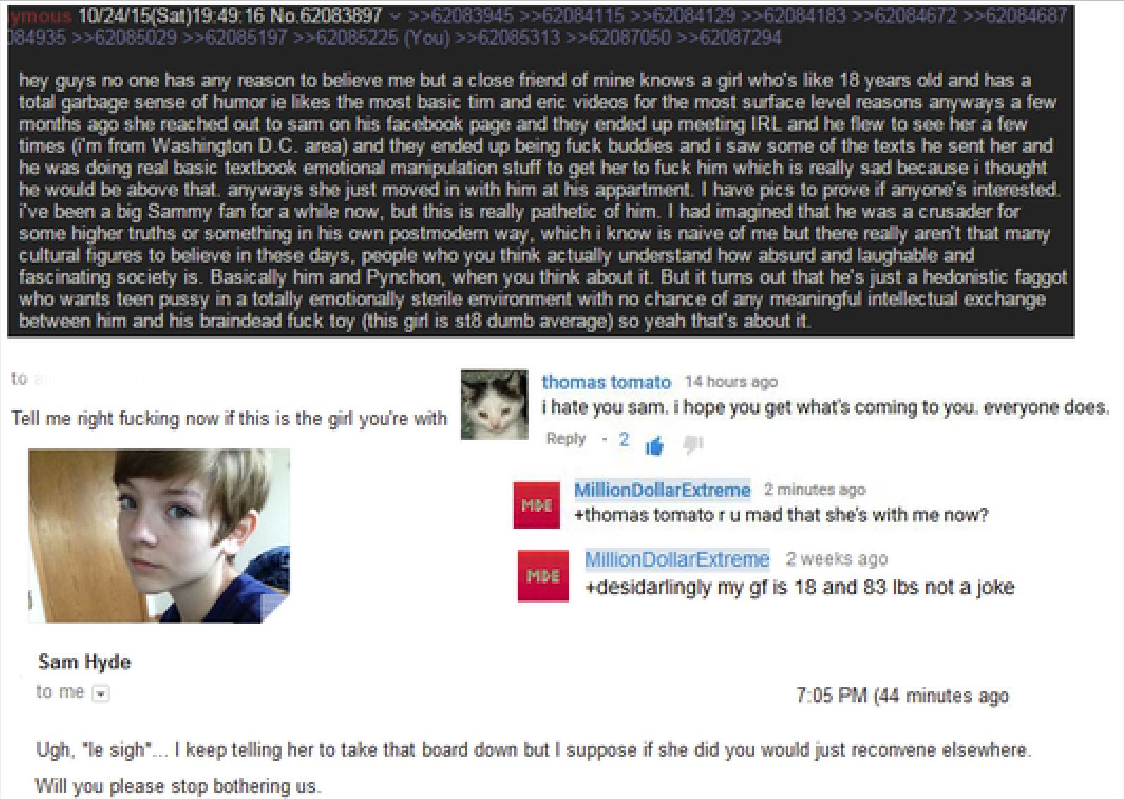

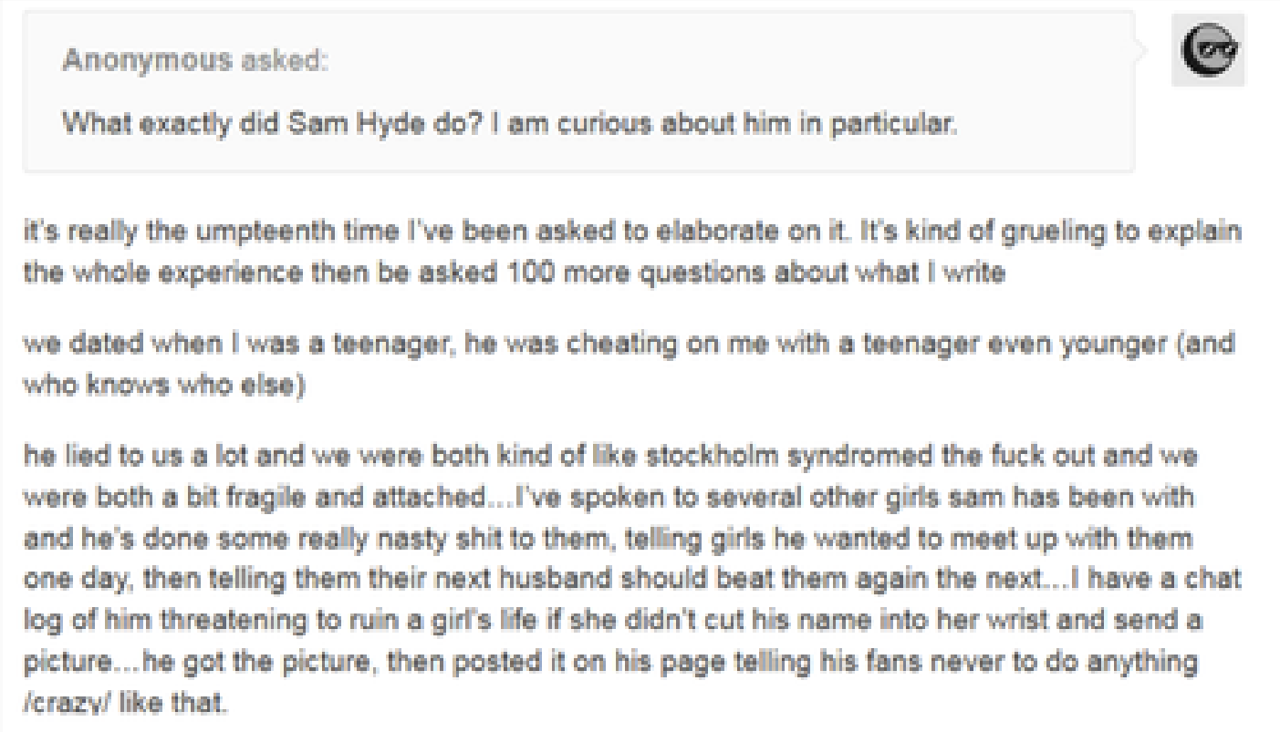

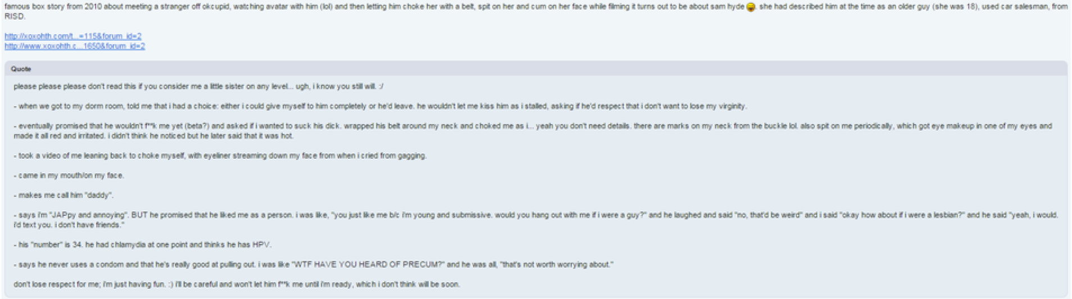

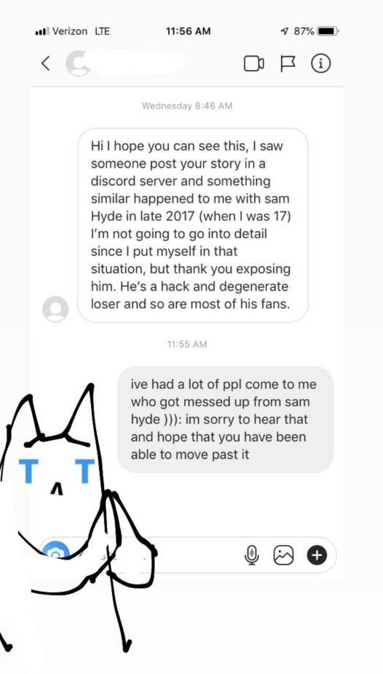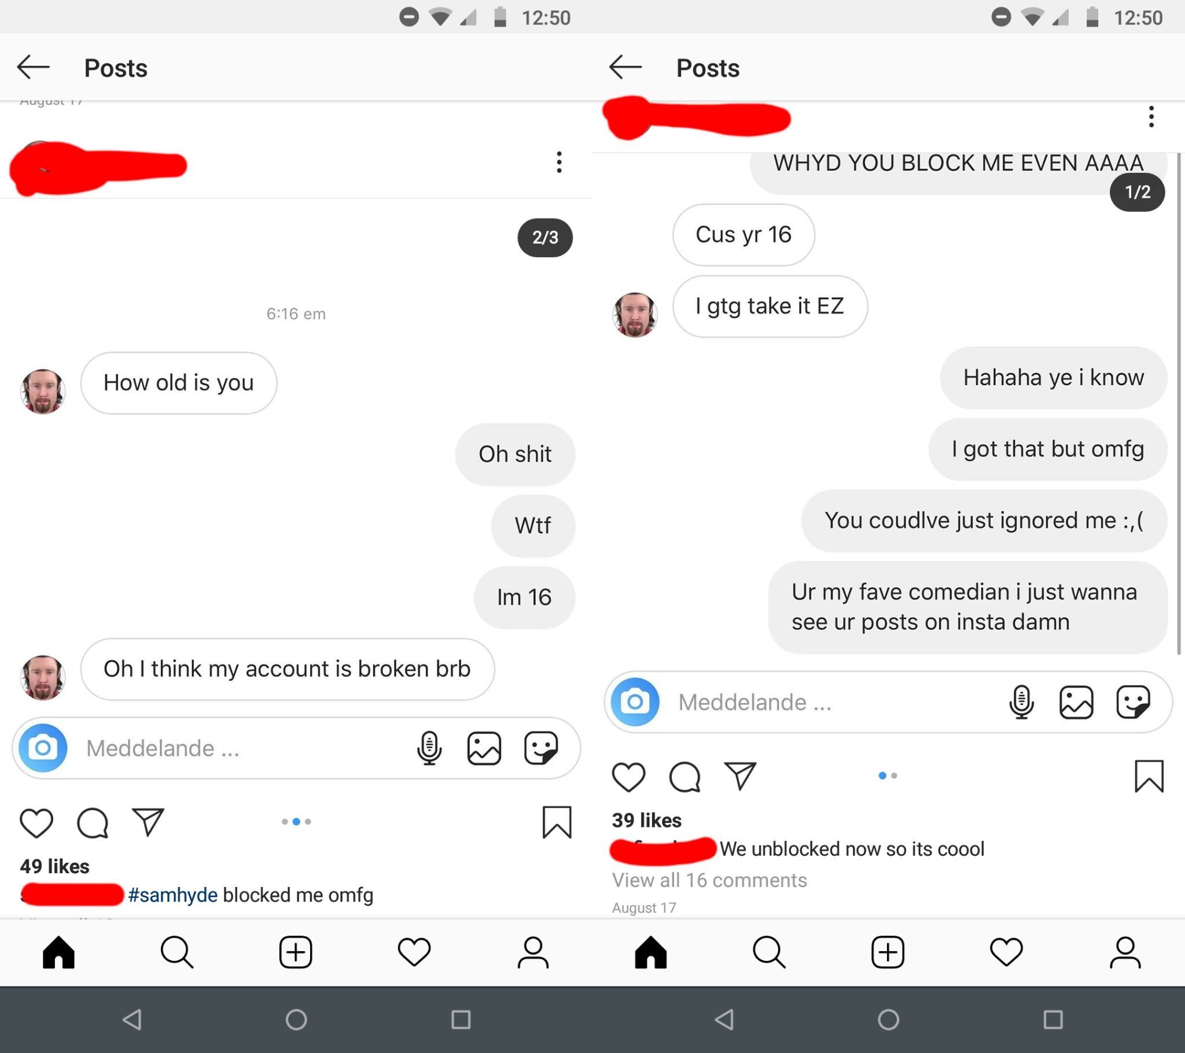

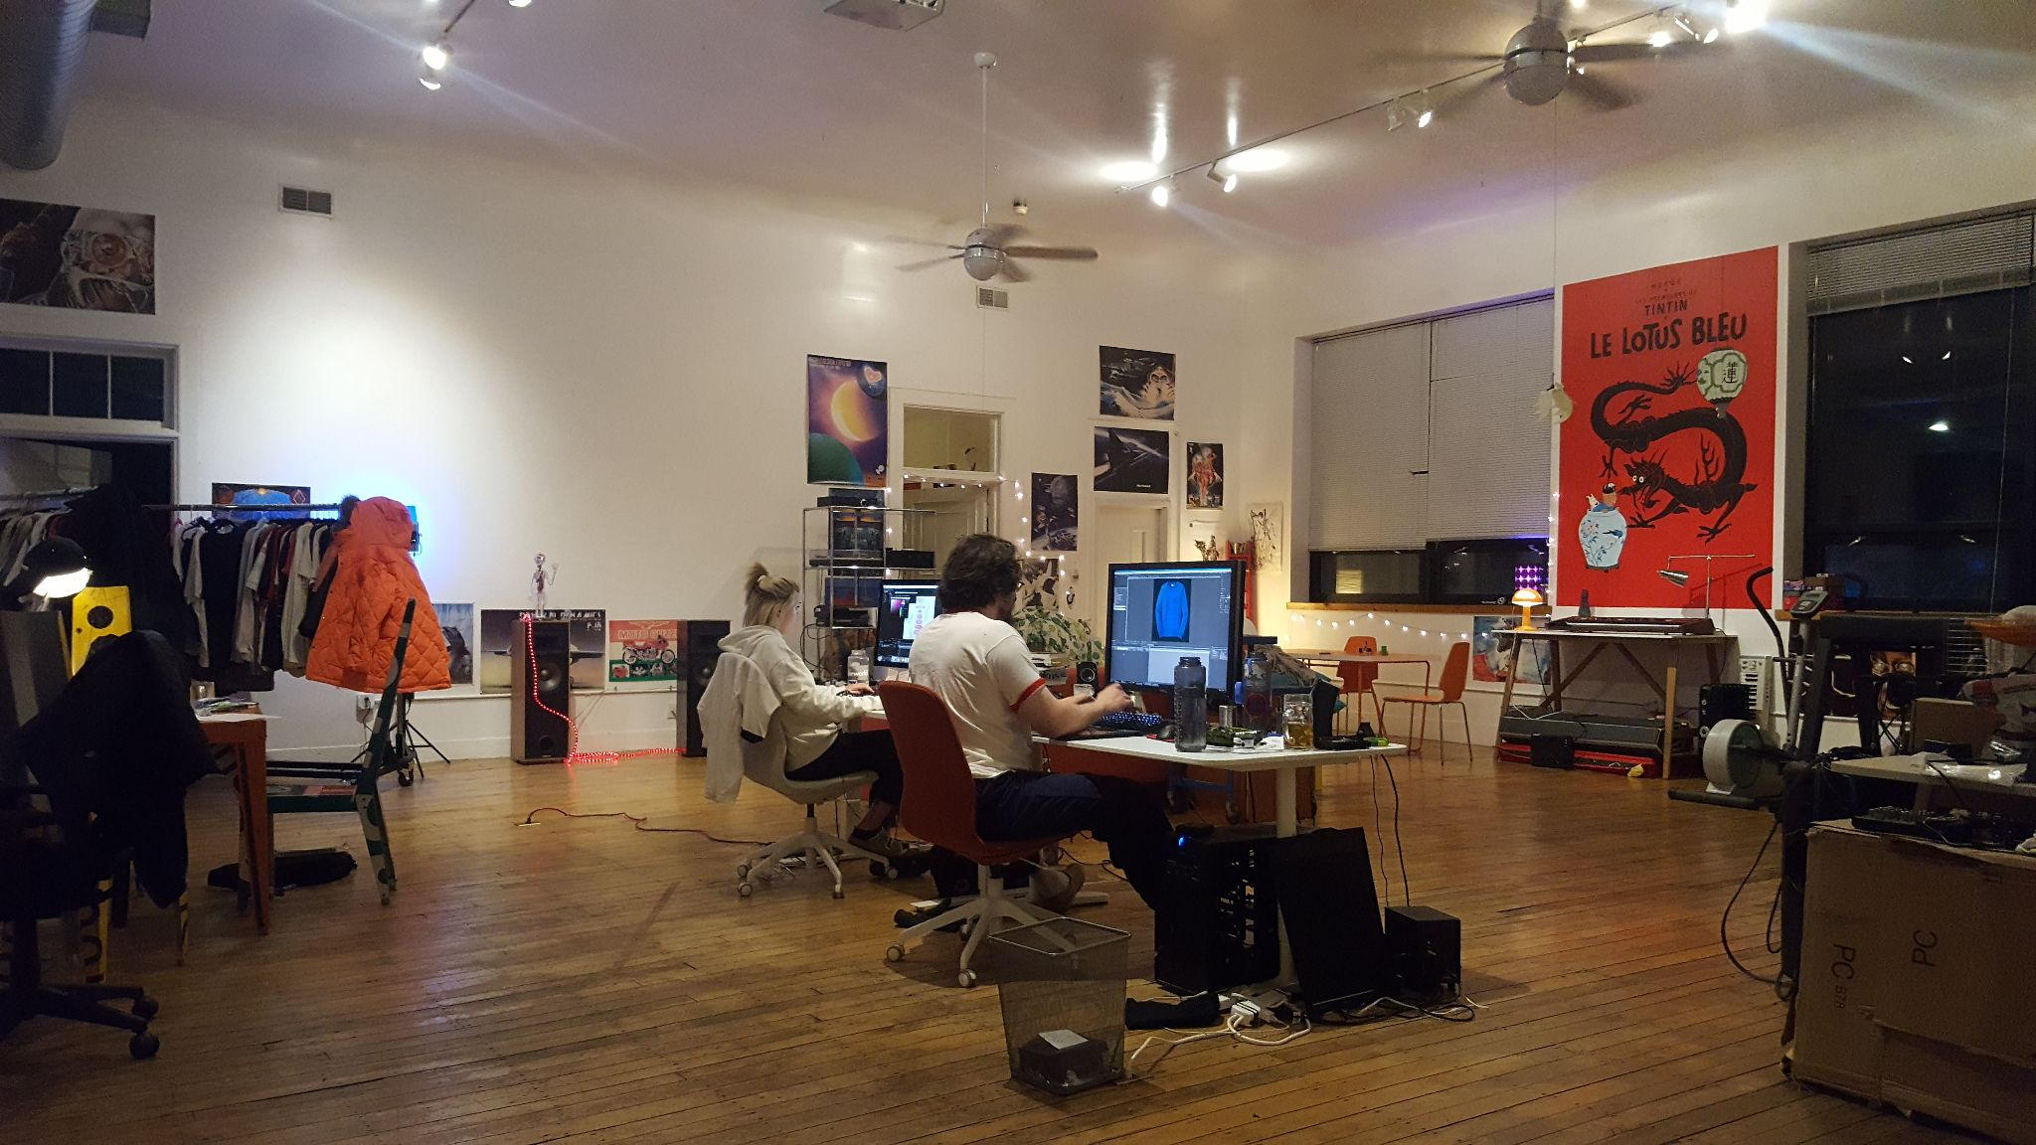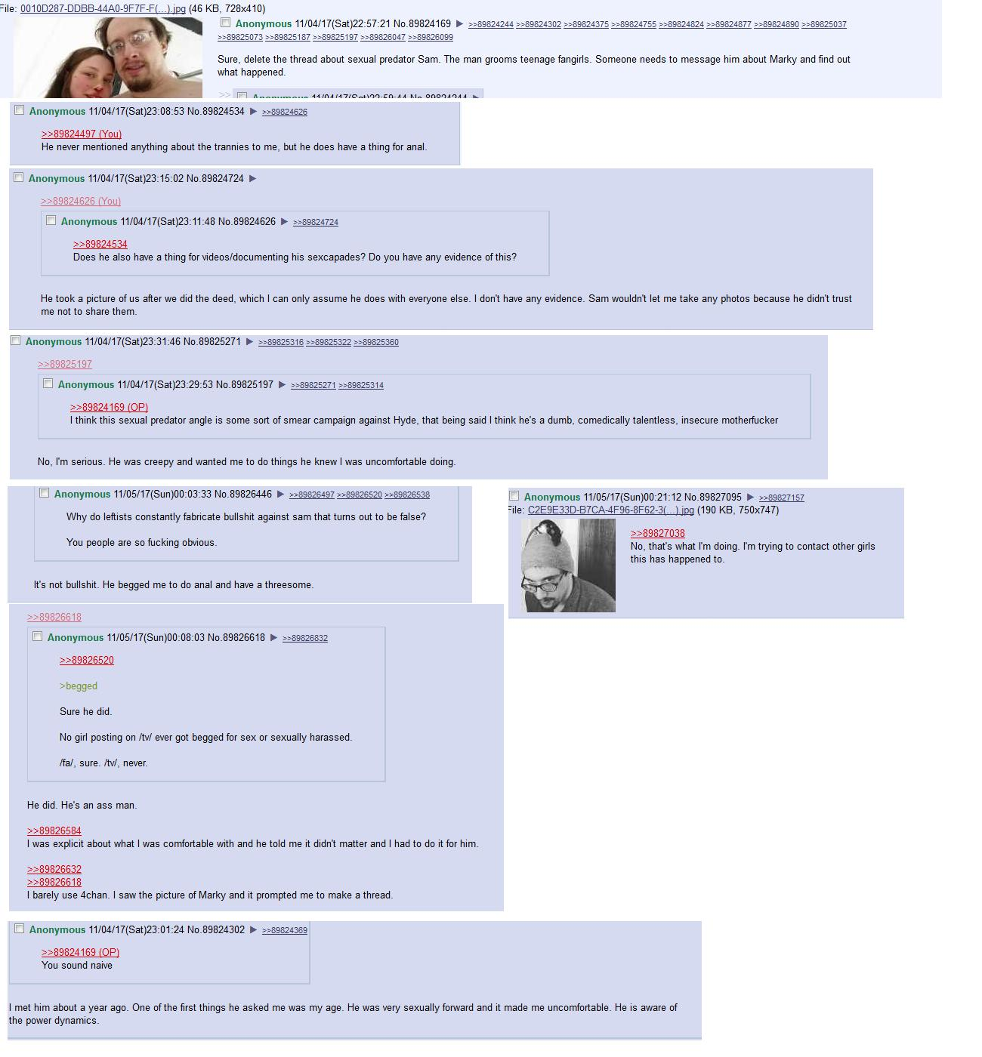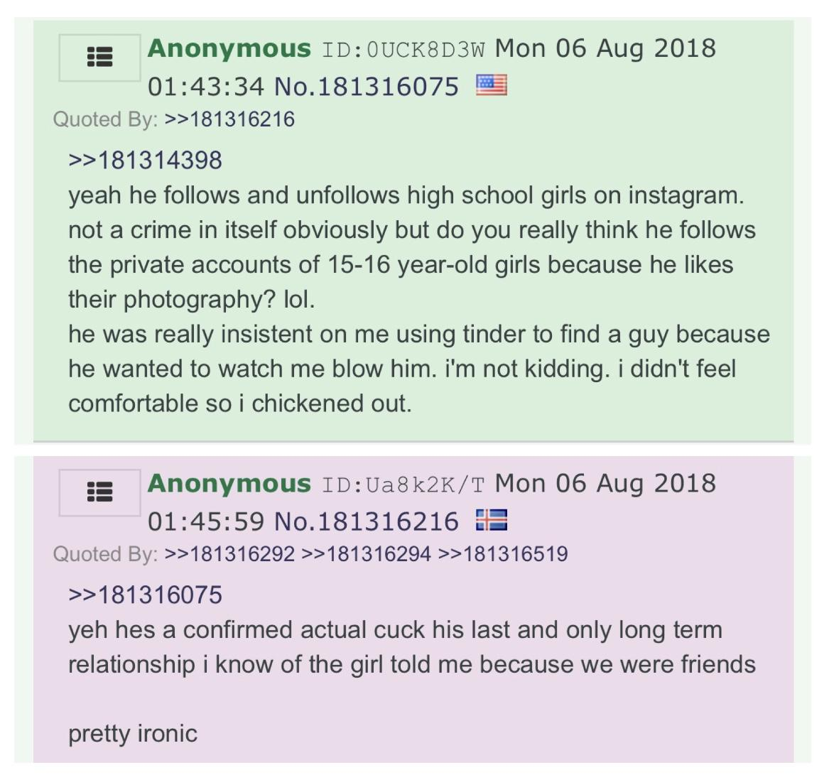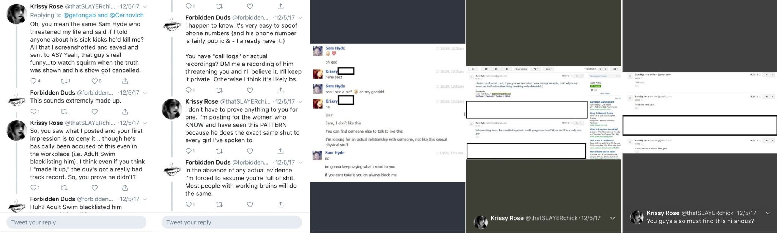

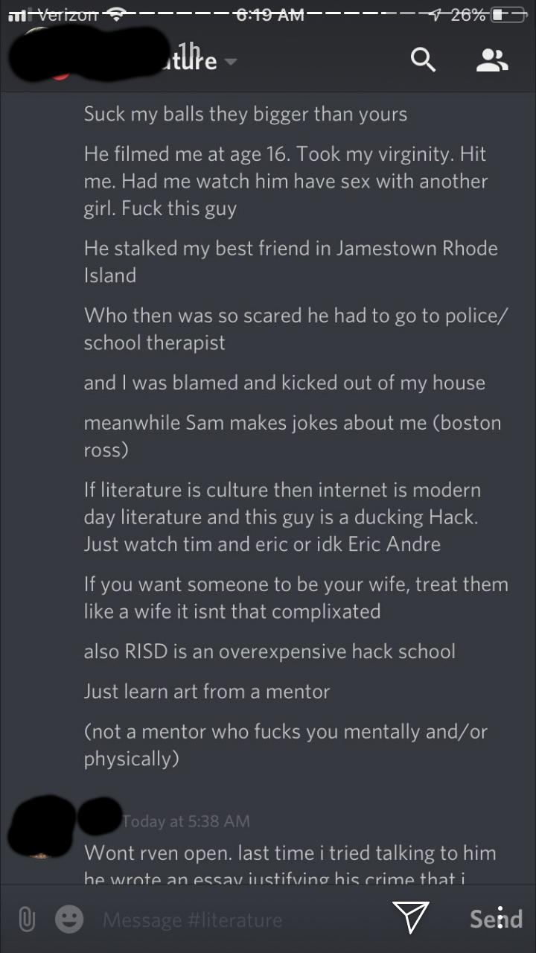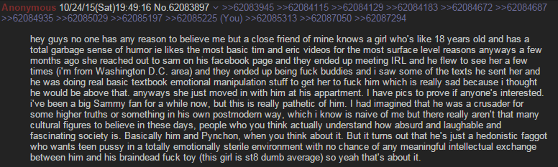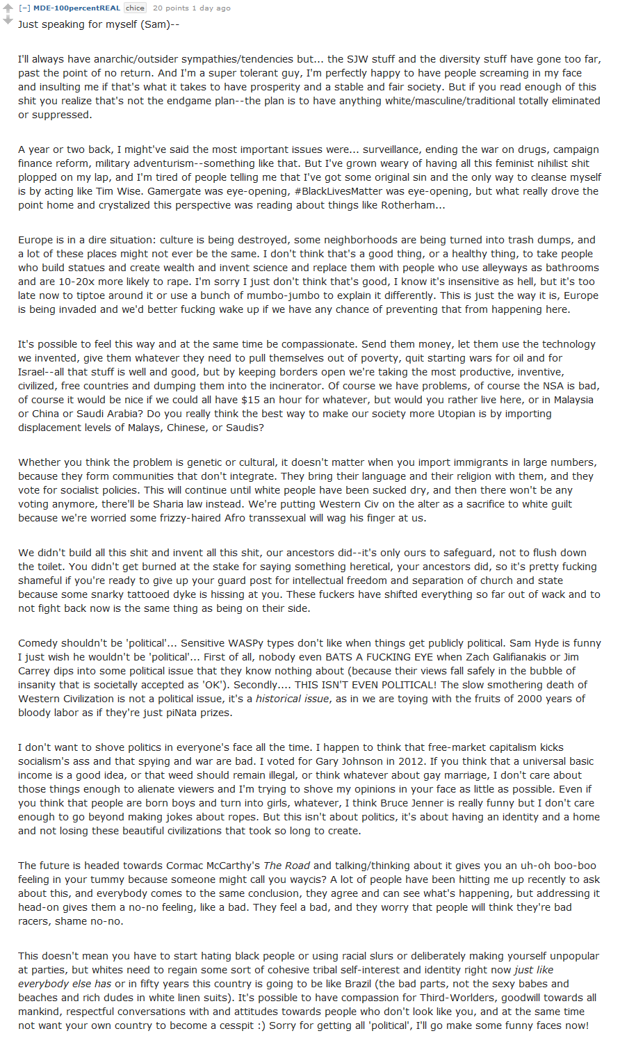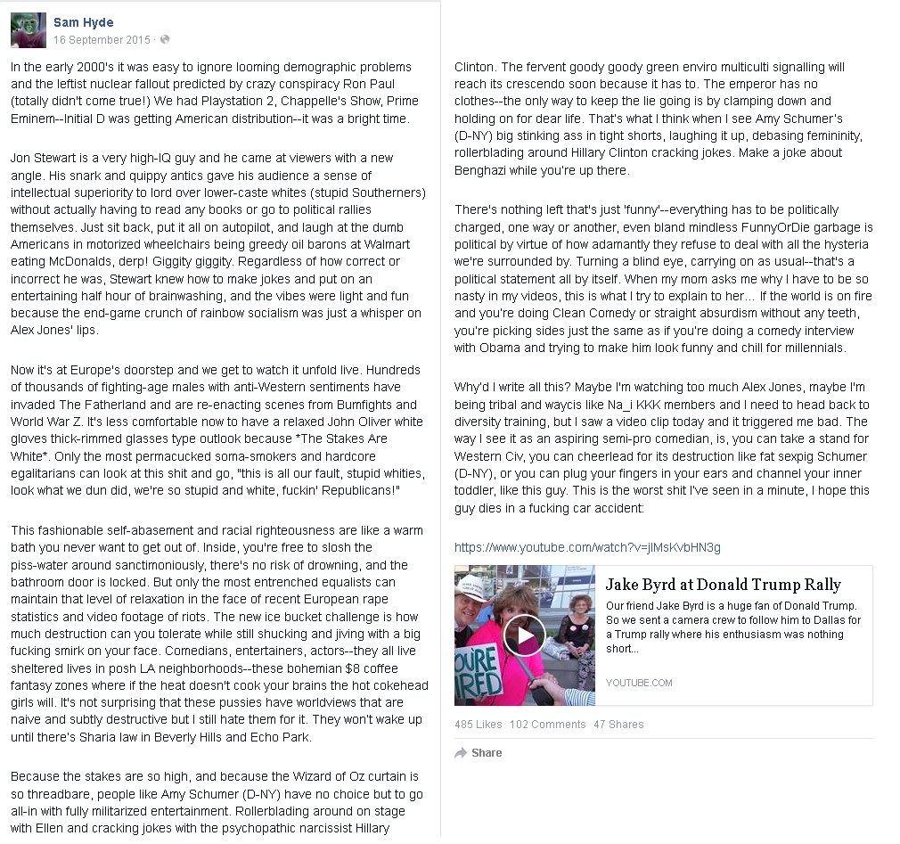

---INSERT SAM VOC FBI STORY---

---INSERT TRACTOR ANALOGY SAM VIDEO PREDICTING HIS FATE---